$124 per person (one day ticket to Disneyland)

+ $10 per person (MAXpass, mobile FASTPASS)

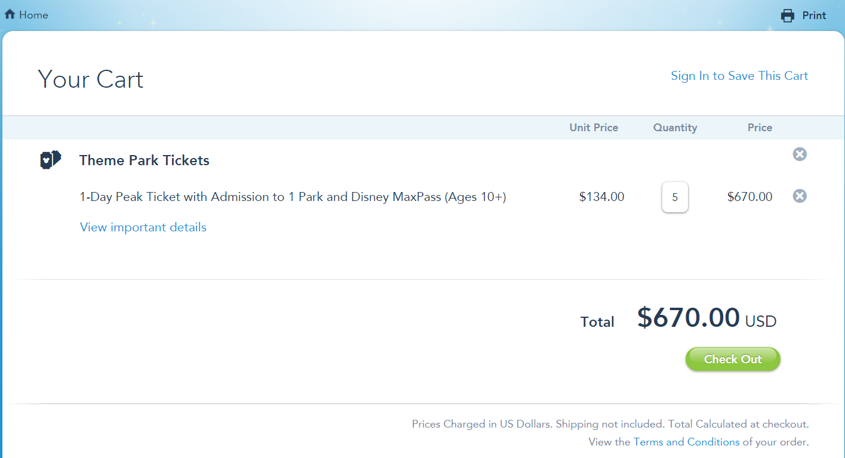

+ $4 per person (parking price)

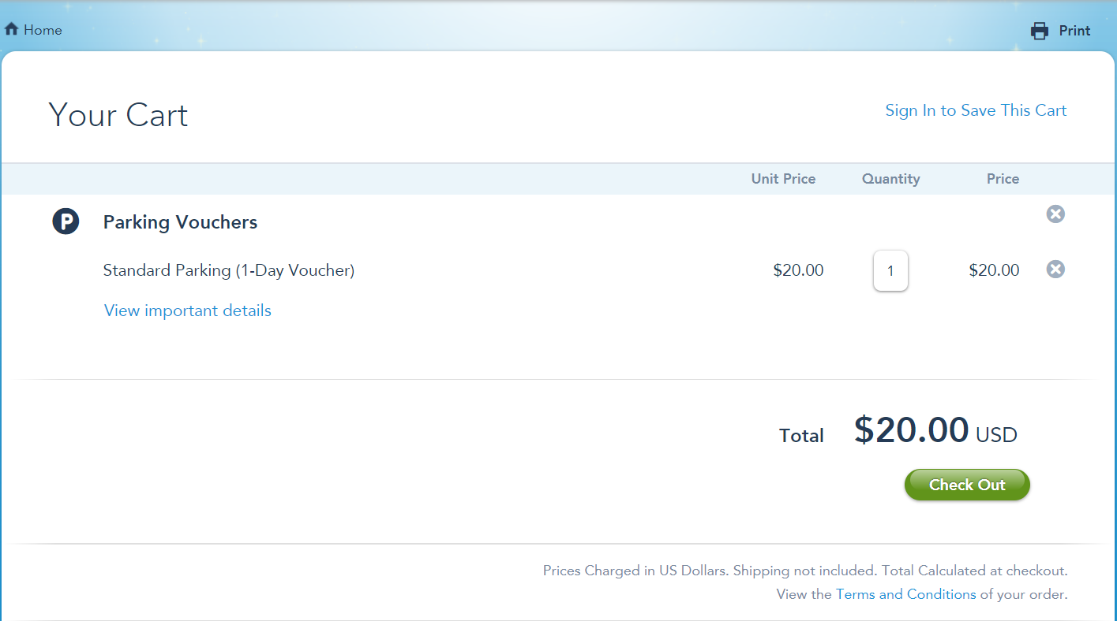

+ $3 per person (locker)

+ $15 per person (breakfast) Carnation Café at Main Stre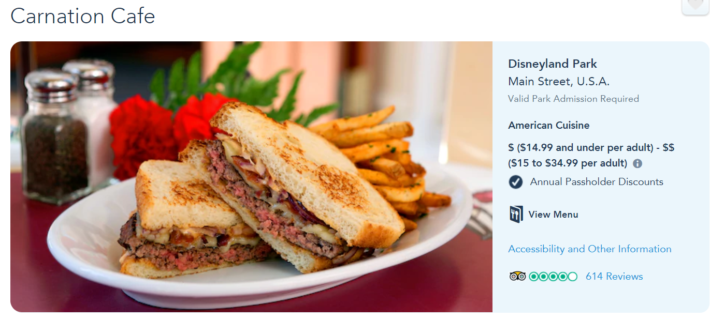+ $15 per person (lunch) Bengal Barbecue

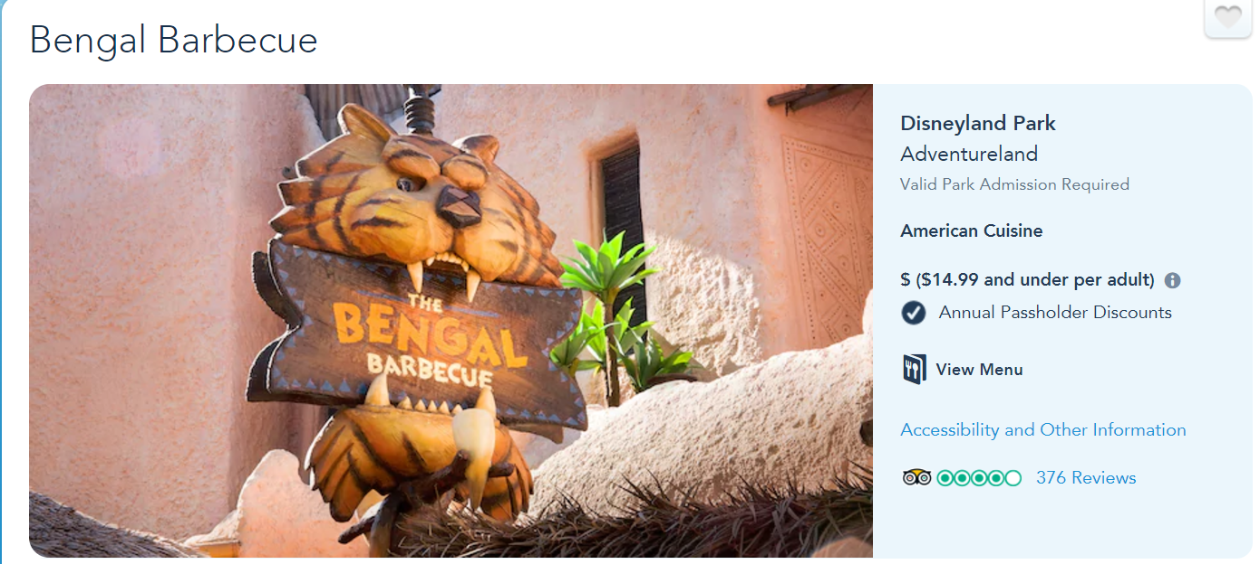

+ $65 per person (supper) Fantasmic! Dining Packages @ Blue Bayou

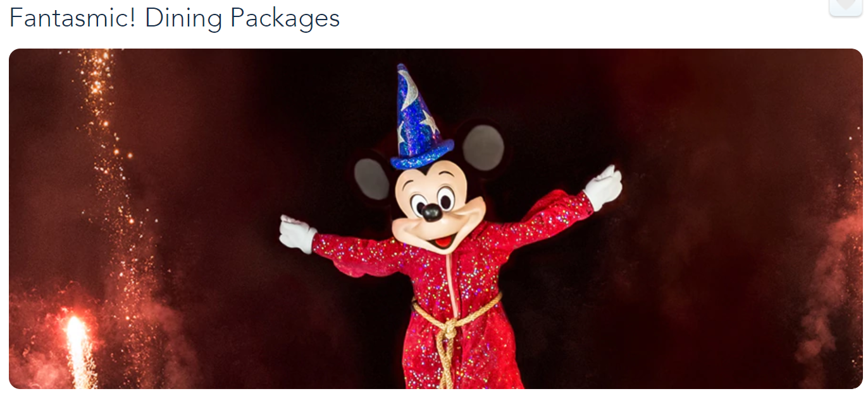

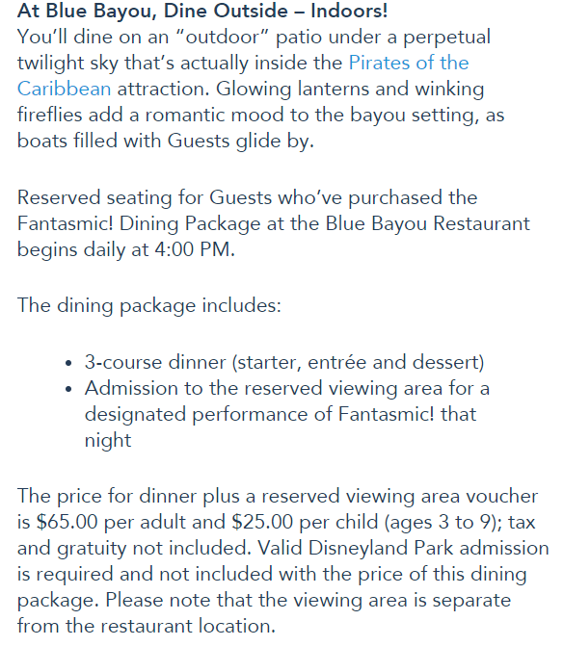

$236 per person